January 28, 2016

The Hon. Bill Morneau
Minister of Finance
House of Commons
Ottawa, ON K1A 0A6

Dear Minister Morneau and Minister Lebouthillier

The Canadian Federation of Independent Business (CFIB) is a non-partisan, not-for-profit political action organization representing the interests of 109,000 small- and medium-sized enterprises (SMEs) across Canada, including many that run self-storage facilities. We are writing to seek some consideration for self-storage facilities caught between CRA imposing penalties and an ongoing Finance review meant to address the issues now facing some of these members.

The 2015 federal budget included a commitment to review the Active vs. Passive income rules. This was welcome news as we had increasingly found that many small business owners that ran self-storage facilities and campgrounds were operating active businesses from which they drew their primary income. However, these businesses were sometimes deemed by CRA to be earning passive income and therefore denied access to the small business tax deduction simply because they had chosen a specific type of business and had fewer than five employees. As a result they were charged at the much higher personal income tax rate, and had to pay thousands of dollars in taxes owed — sometimes resulting in devastating economic consequences to the business. We believe that these types of tax rules are too simplistic and do not reflect the changing marketplace nor the realities associated with running these types of businesses.

Finance did launch the review of the active vs. passive rules in late spring 2015, but given the election and change in government, no further activity seems to have taken place since then. While we understand the reasons for the delay, it has started to cause problems with some self-storage facilities. Over the course of the past few months, many self-storage business owners from across the country have received a letter from CRA asking that they provide supporting evidence / documentation demonstrating their eligibility to access the small business tax rate on an active business income. We understand that this activity is considered to be standard practice, and is fully consistent with CRA’s governing legislation, but it has created a lot of anxiety within the self-storage community.

Furthermore, some of that anxiety seems to have been well founded as one our members has now been deemed as a business with passive income, and has been asked to pay over $33,000 in back taxes simply because they have fewer than five employees and despite the fact that this business is their principle source of income. For a small business, this is a substantial amount of money to absorb, and could likely impact the future of their business should they not be able to access the small business tax rate moving forward.

It is our understanding that this is an active review by the department of Finance that got delayed as a result of the change in government. However, we are concerned that CRA may continue to target more such facilities using the current rules that are the subject of this review. It was clearly viewed by the department of Finance that these rules required another look, so until a decision is made we would suggest that any money owing to CRA by a self-storage facility or similar type of business, such as a campground, deemed to be passive income be put on hold (with no interest accumulating) pending the results from the review. Once the review is complete, these cases can then be re-assessed under the new rules to determine if money is still owed.

Thank you for your attention to this matter. For your information, we have included a copy of our submission to the active vs. passive review from earlier this year. We look forward to your response, and if you have any questions or would like to discuss this further, please feel free to contact me at 613-235-2373 or corinne.pohlmann@cfib.ca.

Sincerely,
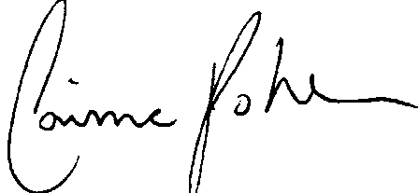

Corinne Pohlmann
Senior Vice-President, National Affairs

