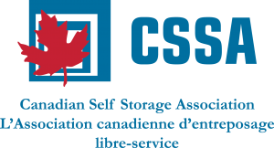

CANADIAN SELF STORAGE ASSOCIATION
YOUNG OPERATORS LEADERSHIP COUNCIL
Registration Form

Young Operator (Y.O.) Name: _______________________________________________________________

Name of Storage Company: _________________________________________________________________

Business Address of Y.O.: ___________________________________________________________________

City/Town: ___________________________Prov.:______________ Postal Code:___________________

Business Phone: (______)___________________ Cell Phone: (______)_______________________

Job Title of Y.O.: _____________________________________ Years working in Self Storage ______

Are you the next generation of your self storage business? Y N
What are your hobbies and interests outside of the storage industry?__________________

Why are you interested in being a part of the Young Operators Leadership Council?

_________________________________________________________________________________________________
Are you planning to attend the 2017 SSA Fall Conference in Las Vegas Sept. 5-7, 2017? Y N
Are you planning to attend the C.S.S.A. 11th Annual Alberta Conference in Red Deer, Alberta on October 19 and 20, 2017? Y N
Are you planning to attend the C.S.S.A. 12th Annual Ontario Conference in Toronto on November 9 and 10, 2017? Y N
Upon completion of this form, please email it back to us at info@cssa.ca If you have any questions, please feel free to contact Sue at 1-888-898-8538. Thank you!

